MK2 STUDY GUIDE

MK2 PQG CERTIFICATION PACKET

NEM COMDTINST M9000.6E

MK3 CARPENTER

ELECTRICITY

Components

- Printed Circuit Board (PCB): board on which transistors, resistors, and microprocessors are mounted, contains circuitry that manipulates data.
- Input/Output Card (I/O Card): PCB that interfaces between external devices and the components microprocessor.
- Central Processing Unit (CPU): Microprocessor or “brains”
- Light Emitting Diode (LED): lights up when electricity passes through.
- DIN/Mounting Rail: allows for connection of components to a rail, provides for common potential earth (ground).
- Electronic Module: fully enclosed component housing, shockproof module, houses PCB
- Terminal Strip, Terminal Block: has terminals for connecting wiring.
- Terminal Connection Box: when connections for system collocated.
- Jumper: allows users to configure devices/change their operation by connecting or breaking circuits; small piece of plastic and metal placed across two circuit ends.
- Pin Connector: a cable; most common type is a cannon plug. To check continuity, put jumper on 1 end and put voltmeter on corresponding end.
- Ribbon Cable: thin, flat, multiconductor cable.
- Slot and Pin Connection: provide connection point for PCB’s

Safety

Electrostatic Discharge (ESD): sensitivity of electrical components to static charge.

Static Shock: 3,000 V

Damage at: 1,000 V
Components may be protected by:
Grounding: antistatic mats and wrist strap
Isolation: static shield bags
Prevention (most important)

POTABLE WATER SYSTEMS

Potable Water: Water Suitable for human consumption.
Freshwater: Water desalinated but not for consumption.

MUST BE APPROVED BY:

US Public Health Service
US Navy Medical Rep.
US Gov’t Rep.

2 APPROVED HALOGENS:

Bromine

Chlorine
Contamination may occur during:
Production
Handling
Storage
Distribution
BROMINE
Safety:
- Water w/ bromine levers greater than 2.7 mg/l don’t use.
- Oxidizer; it will attack plastic, rubber, and coatings
- Keep in closed container
- Do not breathe vapors
- Isolate from heat/ignition source
- Wear PPE (gloves, face mask, goggles)
First Aid:
- Move to fresh air, no induce vomiting
- Flush skin 30 min.
- Flush eyes 30 min.

CHLORINE
Safety:
- May cause fire, burns, water reactive
- Tight, closed container; cool, dry area
- Keep away from heat/ignition, and organic/oxidizable materials
- Do not store on wood floors
- Empty containers are hazardous
- Ventilation, NIOSH approved respiration, gloves and goggles
First Aid:
- Move to fresh air, no induce vomiting
- Flush skin 15 min
- Flush eyes 15 min

PROPER BROMINE/CHLORINE LEVELS
Free Available Chlorine (FAC): Amt. C in water 30 min after initial treatment (.2ppm)
Total Bromine Residual (TBR): Amt. B in water 30 min after initial treatment (.2ppm)
Tests Performed:
- Cartridge changes
- After 30 min contact period in tnk
- Before putting P/W into service
When testing, take sample from tap farthest from P/W TNK and run tap to clear the line.
Initial Concentration:

CHLORINE: 1.0

BROMINE: 0.7
Types of Test Kits:
- Manufacturer’s Chlorine/Bromine test kits: must compare test sample to a blank
- Chlorimeters: electronic device that is more accurate
- DPD Test Kits: determine Chlorine or Bromine residuals.
 | Chlorine | Bromine
Low Range | .01-1.0 ppm | 0.2-2.2 ppm
High Range | 2.0-10.0 ppm | 4.4-22.2 ppm

When taking water on board, the FAC and pH (hydrogen ion content) are determined. If FAC/TBR is > 0.2 ppm and pH is < 8.5, after a 30 min contact period, no additional treatment is required.
CHLORINE: If pH is > 8.5, treat water to produce a minimum 0.6 FAC
BROMINE: If pH is > 9.5, treat water to produce a minimum 0.6 TBR

BROMINE TREATMENT
Automatic Proportioning Brominator: installed in distillate discharge line. It provides initial treatment of distillate before it reaches the P/W TNK.
- Bypass header assemble
- Dual feed valve assembly (adjust flow rates through diff sized orifices)
- Feeder assembly (pressure vessel housing bromine cartridge)
Recirculating Brominator: Recirculates water to and from a P/W TNK. It provides supplemental treatment of water when the TBR degrades below the acceptable level.

CHLORINE TREATMENT
- Considered least desirable because it may result in overchlorination and expose P/W to possible contamination.
- Proper dosages determined by volume of water to be disinfected.

DOCUMENTATION OF TESTS AND TREATMENT
- 2 year chronological record.
- Monthly, with daily entries

REVERSE OSMOSIS SYSTEM

RO desalinization units provide fresh water by filtering seawater through a semipermeable membrane under pressure.

REMOVES:
- Bacteria
- Salts
- Sugars
- Proteins
- Dyes
- Constituents w/ molecular weight > 150-250 Daltons
Crossflow operation: seawater passes over membrane, w/ only 20-30% passing through the membrane. The salt stays in the feed solution, which is discharged overboard.
Particle size: ions (charged molecular particles) are separated because of limited diffusion through the membrane.
Osmotic Pressure: osmotic pressure exists between the saline and pure water sides of membrane.
NORMAL OSMOSIS: under natural conditions, if a semipermeable membrane separates 2 solutions w/ diff concentrations, solvent will pass from the weak to the strong side, decreasing concentration of the strong side. Resulting osmotic pressure will be about 350 psi.
REVERSE OSMOSIS: When pressure (700-1000 psi) is exerted on the strong concentrated side of the membrane, water will pass from the strong to the weak side, making a diluted solution. The membrane rejects sea salt and dissolves it away.
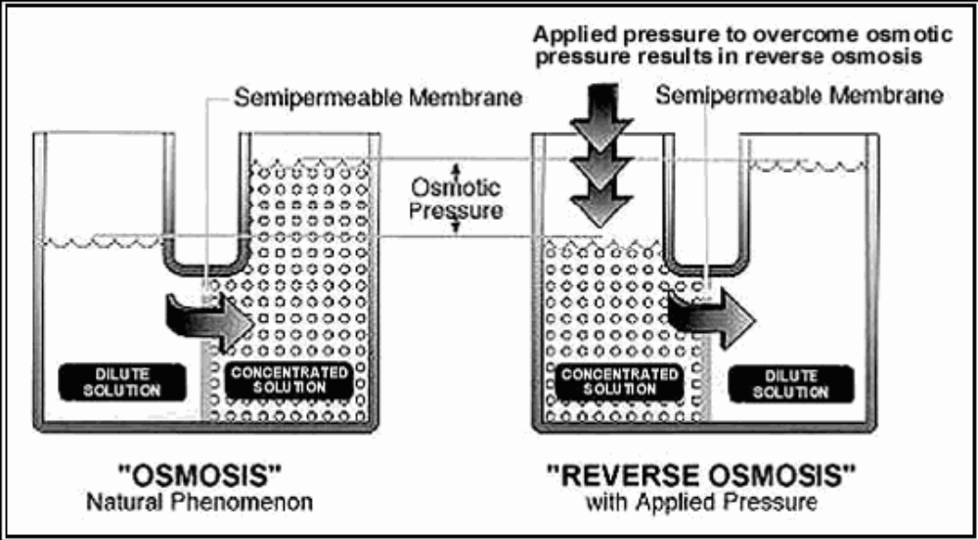

COMPONENTS
- Duplex strainer
- Centrifugal separator (heavy suspended particles removed; removes 98% of separable solids 74 microns and larger)
- Heater (prevents freezing on freshwater side; seawater freezes at 28.6*F, and freshwater at 32*F)
- Cartridge filters (staged sequence of 30-10 micron filters)
- Activated carbon filter (removes Bromine/Chlorine, which is harmful to membrane)
- Backflow preventer
- Feed booster pump (ensures a positive pressure is kept at suction end of HP pump)
- High pressure pump (increases pressure to 700-1000 psi)
- RO module (contains membrane elements; pressurized seawater flows across membrane, and freshwater passes through as salts are rejected)
- Brine restrictor vlv assembly (sets system pressure)
- Flowmeter (monitor brine and permeate)
- Dump vlv (3 way solenoid that diverts permeate to either bilge or P/W TNK if less than 500 ppm Total Dissolved Solids or 1000 microohms/cm conductivity)
- Relief vlv
- Main control panel
- Salinity indicating panel (monitors salinity and conductivity)
- Gauge panel
- Programmable Logic Controllers (controls machine based on input)
YELLOW ALARM: cautions operator
RED ALARM: prevent system startup
- Pressure switches (shutoff HP pump and indicate when cartridge filters need replacement.
Safety:
- Tools and personnel clear
- Don’t operate machinery w/ damaged components
- Make sure pressure relief vlvs are unobstructed
- Don’t operate RO when dump vlv is locked in the “permeate to TNK” position
- Keep body parts away from rotating equip
- Before servicing RO, shutoff power, close vlvs, open and vent drain lines, tag out unit.

CHANGE FILTER MEMBRANE WHEN:
- Water output drops by 10-15% during first 48 hrs of operation
- Total Dissolved Solids exceeds 500 ppm

PNEUMATIC SYSTEMS

Most common type is reciprocating type, available in single- or multi-staged versions.

Positive Displacement Models: compressor takes in volumes of air that are compressed in a confined space to elevate air pressure.

Components
- Receiver (storage tnk when need for air is > capacity of compressor; enables compressor to shut down. Also helps eliminate pulsations in discharge line)
- Moisture Separator (remove moisture from system)
- In-Line Lubricator (applies vapor of oil to lube mechanisms)
- Pressure regulator (lowers high unusable pressure to low usable pressure)
- Pressure relief valve
- Pressure reducing station (change air pressure w/o changing compressors)
- Cross connect station (allows system to change from Ship Service Air to Diesel Start Air; SSA-DSA-SSA)
- Diesel air start motor (convert potential energy in form of compressed air to mechanical energy; the required air for engine start-up is 150-250 psi; the discharge silencer acts as a muffler)

Ship’s Service Air
Function: to supply air at the required pressure and flow rate to meet demands of shipboard services.

Diesel Start Air
Function: produce air for start up.
Each air bank has minimum capacity for ONE cold start and NINE hot starts without recharging. Air bank is normally located in the same compartment as the engine it serves.

Safety
- Avoid rapid operation of manual valves; heat of compression may cause explosion. Pressure rise should be kept under 200 psi/sec
- No heat or sharp blow to system or components
- No stop/check valve between compressor and receiver.
- Do not leave system until ensure working properly
- Do not repair leak while still under pressure
- Before working on system: tag-out and secure, blow down and relieve pressure, close valves, utilize double valve protection.
- Do not operate compressor in temps above 104*F

OILY WATER SEPARATORS

Operate on the principal of coalescing, which is the natural ability of two dissimilar liquids to separate.

Two types of OWS systems: the PRESSURIZED TYPE and the VACUUM/GRAVITY TYPE.
- Prefilter: a pleated paper filter used to remove small particles such as shavings and dirt form the mixture.
- Standard Coalescer: Perforated fiberboard or metal center core with multiple layers of spun fiberglass in the core. Flow is inside to outside.
- Combination Coalescer: Used for both prefiltering and coalescing together. Flow is inside to outside.

Pressurized System Components
- Pressure vessels: metal containers that house the filtering device; where separation takes place.
- Automatic Air eliminator: installed on the first stage vessel; removes air from system
- Manual air bleed valves: installed on systems w/ no auto air eliminator
- Sight glasses
- Bull’s eye sight glass: on vessels where coalescing takes place; on bottom of vessel to look for graping
*GRAPING: when oil or water don’t separate (33*F or damaged components)
- Oil level probes: monitor oil level and initiates oil dump
- Solenoid valves
- Pressure differential gauges
- OCA: giver oil in water measurements, auto operation.

First stage: pre-filter stage
Second stage: coalescing stage; majority of oil removed.
Third Stage: polishing stage; houses one coalescing element.
The oil content alarm decides when to pump the water overboard.

IF oil content is below 15 ppm, THEN OCA pumps overboard
IF oil content is above 15 ppm, THEN OCA recirculates mixture.

Vacuum/Gravity System Components
- Vacuum gravity vessel: first stage, houses a set of inclined absorption plates; meets 100 ppm oil content level requirement
- Oil pump: pump removes oil from first stage under vacuum; pump is a progressive cavity, positive displacement pump
- Gauge panel
- Inclined adsorption plates: mixture enters bottom of plate, oil stays, and water is pulled through to the top.
- Float switch
- Water pump: creates vacuum for first stage and provides flow for second and third stages
- Pressure relief valve
- Check valve:
- Second stage pre-filter: located on pressure side of water pump, contains pre-filter w/ sock that filters and coalesces. Flow is inside to outside.
- Third stage coalescer: houses one standard coalescer, known as polishing stage; oil removed is recirculated back to suction side of first stage.
- Solenoid valves
- Oil detector probe: initiates oil dump.
- OCA: giver oil in water measurements, auto operation

46 CFR 162.050: Vessels greater than 26 feet must have a placard 5X8 in. made of durable material and in machinery space or bilge and at bilge pump controls stating: DISCHARGE OF OIL PROHIBITED. Cannot discharge oil greater then 15 ppm within 12 NM.

33 CFR 155.470: Identifies prohibited spaces for the storage of hazmat.

TROUBLESHOOTING BEARINGS

Life of Bearing: number of revolutions or the hours at some given constant speed before the first evidence of fatigue develops.

Categories of Bearings
1. Plain Bearing: solid surface w/ sliding/rolling contact. Made of softer material than the shaft or slide the bearing will support.
2. Antifriction Bearing: depends on races containing balls or rollers. Friction developed is relatively low. (examples: ball bearing, roller bearing, and needle bearing)
1. Journal Bearings (split precision bearings): radial load of rotating shaft.
2. Thrust Bearings: axial load of shaft; 90* angular contact bearing. One flat surface is moved along a second flat surface that is free to pivot.
3. Frictionless bearings: guiding or supporting rotation components.
1. Radial: limit radial motion
2. Thrust: limit axial motion
3. Radial-thrust: limit radial and axial motion (ball-thrust bearing)

Classification of Bearings
- Movement: Axial and Rotary
- Load (direction): Radial, Thrust, and Radial-Thrust
- Type of surface: Sliding contact and Rolling Contact

Roller Bearing Safety:
- Don’t use machinery in poor condition
- Watch performance of new bearings during run-in period (no load)
- Use correct type
- Never replace balls or rollers
- Don’t remove bearing from package until ready to install
- Seal inner race tight against shaft shoulder
- Don’t over-lubricate
- Protect against foreign matter
Sliding Contact Bearing Safety:
- Avoid contact with rotating shafts
- Secure and tag-out shaft prior to maintenance
- Engage shaft locks
- Avoid igniting lube oil
- Bearings may be heavy
- Keep area clean

Causes of Bearing Failure
- Temperature: load, speed, lubricant, and outside heat sources. Maximum limit for general bearing application: 230* F.
- Noise/Vibration: structure borne, airborne, or fluid borne.
  - Squeaking: insufficient lube or preload
  - Metallic: insufficient clearance/axial preloading
  - Smooth tone: brinelling of races
  - Intermittent : damaged ball bearing
  - Crunching: dirt

- Corrosion: chemical agents attack bearing
- Electrolytes: salts, acids, or alkalis corrode bearing alloys
- Organic Acids: oxygenated/oxidized hydrocarbons
- Contamination:
- Grease lube: check for water, dirt, and oxidation
- Oil Lube: check for water, dirt, and metallic particles
*May cause: scratching, erosion, grooving, plowing, shallow/deep embedment.
- Abusive handling: Do not store in unheated areas or above 120* F. First-in, first-out rule; keep in original packing, don’t drop.
*Brinelling: when the raceways of a ball bearing are deformed due to too much load.
- Improper service inspection

Bearing Inspection

SNAP GAUGE
BORE GAUGE

Cleaning Bearings
- New Bearings: MIL-L-17331 heated to 150* F.
- Used Bearings: SOAK WITH: 2190 TEP oil at 180* + 10* F. FOR 1 HR.
RINSE WITH: 2190 TEP oil at 140* + 10* F. FOR 5 MIN.

Lubricating Bearings (Rolling Element)
- Prevents contact between races and rolling elements
- Lubes sliding contact between cage and other parts
- Lubes sliding contact between rollers and guiding elements
- Protects surfaces from corrosion
- Seals against foreign entry
- Provides cooling
RELUBRICATABLE BEARINGS:Mounted open, single-shield, and single-seal bearings need grease added. Pack bearing cavity 20-30% full.
PRELUBRICATED BEARINGS: Double-shield and double-seal bearings are permanently lubed.
* IF YOU FORCE TOO MUCH GREASE INTO BEARINGS, YOU WILL BLOW OUT THE SEALS.

Renewing Bearings:
Interference fit: the tightness between the shaft and the bearing bore or the housing bore and the bearing outside diameter. Almost all rolling-element applications will require this.
- HEAT SOURCE METHOD: 100* F difference between fitted parts. Slide bearing all the way to shoulder, torque, then re-torque after cooling.
- ARBOR PRESS METHOD: Center bearing at beginning of seat, make sure inner race rests on ring, apply pressure with arbor press ram (you can also use hammer)

REDUCTION GEARS

A Marine Propulsion Unit transmits power from the driving unit to the driven unit.
*For most ICE, both speed and shaft rotation direction are changed.

SPEED RATIO/GEAR RATIO: determined my dividing the # of teeth on driven gear by the number of teeth on the driving gear. (2 to 1, 2:1, 50/25)

TORQUE: force that causes rotational movement of an object.

*Higher gear ratio=greater torque difference
- INDIRECT DRIVE: a drive mechanism that changes speed and torque (marine apps). They reduce engine power using an intermediate drive of gears
- DIRECT DRIVES: used when engines supply power to AUX

Mechanical Drives
  - Reduce shaft speed
  - Reverse direction of shaft rotation
  - Permit quick-disconnect of the driving unit

REDUCTION GEAR: most diesel engines don’t exceed 3:1
REVERSE GEAR: most commonly used method for backing-down power, reverse shaft rotation (smaller engines
CLUTCH: disconnect engine from shaft
TRANSMISSION

Reduction Gears
- Shallow case: 1.45:1, 2:1, 2.48:1, 2.95:1
- Deep case: 3.8:1, 4.5:1
- Twining: 2 gears with same ratios mounted on R or L side with one gear fwd, one gear rvs to obtain opposite rotation of propellers.
- Direction of drive: ENGINE DIRECTION: fwd clutch shaft & rvs driving gear
ANTI-ENG: rvs clutch shaft & rvs driven gear

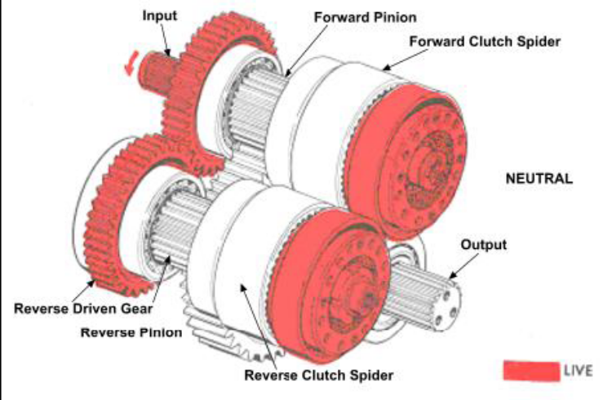

Manifold
- Selector valve
- Oil pump (rotary type driven by splined drive sleeve on reverse clutch shaft)
- Trolling valve assemblies (reduce prop RPM while keeping high engine RPM for accessories)
- Cover for clutches
- Come-home access pipe plugs
- Oil return pipe assembly

Output Shaft
- Output shaft gear
- Output flange
- Oil seals
- Shaft roller bearings
- Tapered roller bearings

General Maintenance
*SAE-API service class CD engine oil certified to pass TO-2 or C-3 inspections –or-

*MIL-L-2104B

SHALLOW CASE: 2.2 Gal.

DEEP CASE: 3.5 Gal.
*Oil change every 1000 hours (gravity drain vs. suction drain)

*Output flange oil seals greased every dockside/100 hours
*Oil breather assembly removed and flushed every 500 hours

Emulsion: Free fatty acids, formed continuously by lube oil that react with the l/o to cause emulsification.

RUDDER BEARINGS

Rudder Bearing tolerance readings taken yearly in boat inspection report (3022). One report is made, submit to MLC within 10 days.

*Made of synthetic phenolic resin compound

1. Stave bearings 2. Smooth bearings

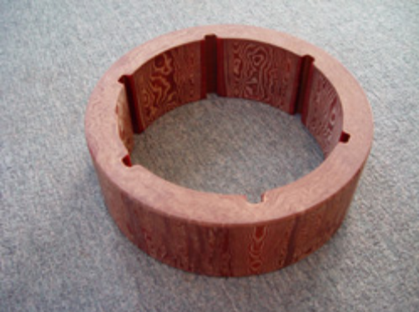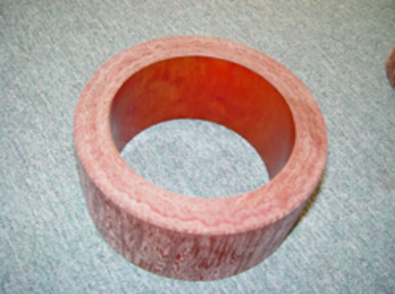

DIAMETER BEARING CLEARANCES
Outside diameter of rudder stock | Min operating diametric bearing clearance (in) | Max operating diametric bearing clearance (in)
1” | .005 | .050
2” | .005 | .050
3” | .006 | .060

*If outside acceptable tolerances, may cause:
1. Imprecise and poor steering response
2. excessive vibration
3. leakage through the rudder post housing

Inspection of rudder bearings
- Take feeler gauge readings for all 4 pos. around the shaft.
- Add P&S, F&A measurements together

OUTBOARD ELECTRICAL SYSTEMS

Electronic Control and Monitoring System (ECM):
  - controls ignition timing, fuel timing, and quantity
  - monitors operation of engine
  - alerts operator of problems

Starting system
Components:
- key/ignition switch
- starter solenoid
- starter motor
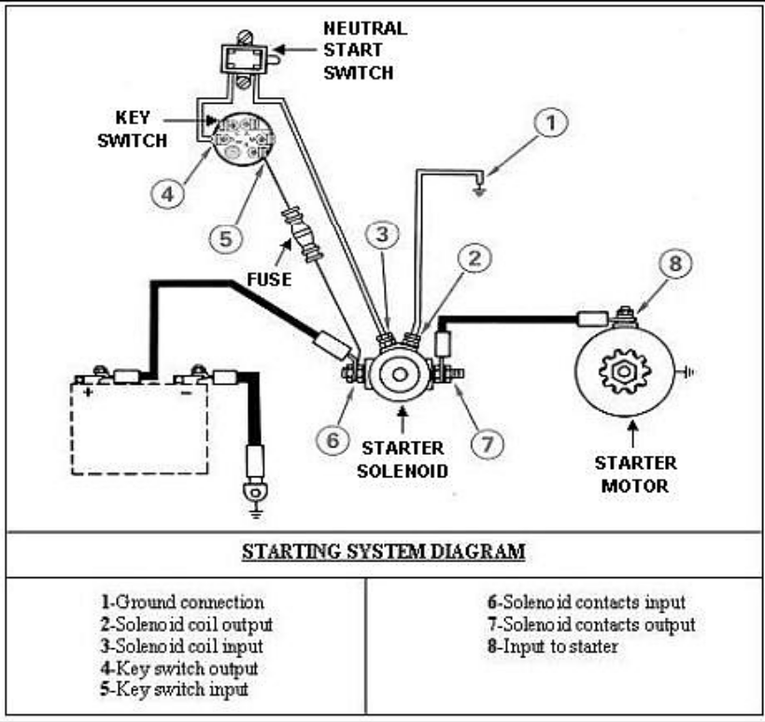

*check for continuity/resistance using a multimeter
*make sure key clicks into pos. without any sloppiness or play.

Charging System
*converts mechanical energy to electrical energy.
Components
- battery
- alternator
- rectifier
- voltage regulator
PERMANENT MAGNET ALTERNATOR: use magnets bonded to flywheel rotating around stationary coils. (small Hp outboards)
VARIABLE-FIELD ALTERNATOR: has rotor that is an electromagnet energized by battery and driven by a belt. It rotates inside a stator or set of charging coils (large Hp outboards)
*Two possible problems for charging system:
1. overcharging (battery)
2. no charging (check w/ multimeter, then replace altenator)

Ignition System
*two main types:
1. TRANSISTORIZED MAGNETO (TMI)
2. CAPACITIVE DISCHARGE IGNITION (CDI)*most common in CG units

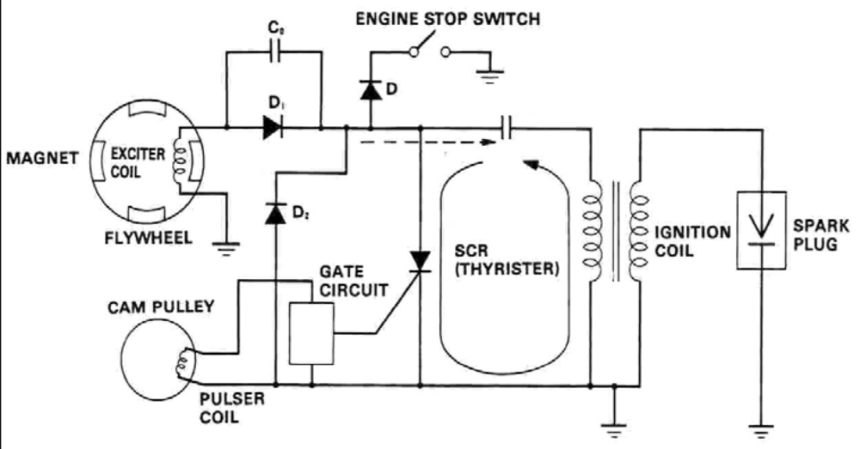

CAPACITIVE DISCHARGE IGNITION

OUTBOARD MECHANICAL SYSTEMS

*HARD STARTING ENGINES: Ignition, Fuel, and Compression.

Fuel System
- Fuel Tank
- Filters
- Pump
- Lines
- Carburetor/Fuel injectors
*To inspect the Carburetor, all parts must be cleaned (remove and disassemble)

Compression
*If f/o is good and flows freely, next worry about the cylinder compression.
Possible causes of low/variable cylinder compression:
- Damaged head gasket
- Damaged pistons
- Broken/stuck piston rings
- Scored cylinder walls
- Stuck valves(4stroke)
- Incorrectly adjusted valves (4stroke)
Compression Level | Probable Cause
Low compression in 1 cylinder | Bad exhaust valve
Low compression in 2 adjacent cylinders | Bad head gasket
Low compression in all cylinders | Piston rings and cylinders are worn

Overheating Engine

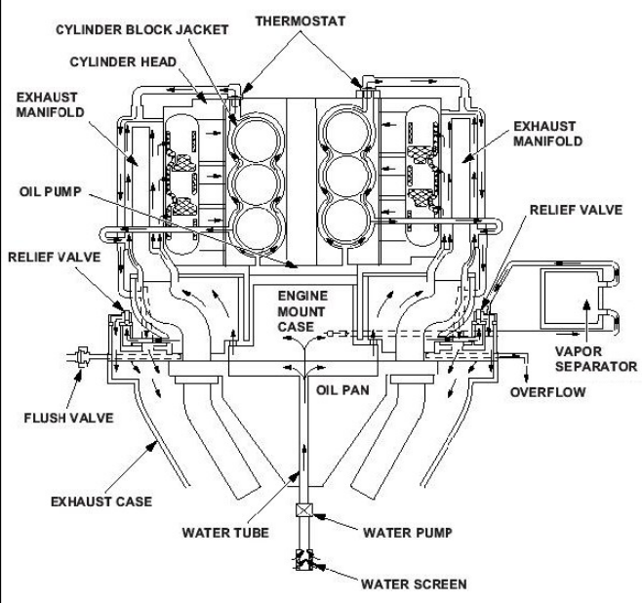

To troubleshoot, test:
- Thermostat
- Overboard/overflow tube
- Pressure relief/bypass valve
- Water pump

Propeller Renewal
*A damaged propeller may cause:
- High fuel consumption
- Lack of Power
- Unexpected Vibration

ENGINE TREND ANALYSIS

PROCESSES USED BY THE USCG:
- DEMPS (Diesel Engine Maintenance Program)
- CATCAMPAR (Caterpillar Computer Aided Marine Performance Analysis Report) (certified CAT tech rep required)
- ODR (Operating Data Recorder)
- Round Sheets

Engine Performance Tests
*A snap shot of engine condition
TESTS:
- When overhaul break-in period complete
- When engine reaches 50% of stated hours
- Every 500 operating hours
*During tests, engines should be operated at 80-90% of CG rated load

*L/O and J/W should be within 5 degrees of normal operating temps
*RPM and Load should be duplicated

DEMPS
  - Full power trials
  - Observation of engine operating characteristics
  - Periodic SPECTRA CHEMICAL ANALYSIS (L/O)
  - Observation of trends of engine operating parameters
  - Physical inspection of engine components
*DEMP Performance Monitoring Indicators, basic readings:
    - cylinder compression pressure
    - cylinder firing pressure
    - cylinder exhaust pressure
    - crankcase vacuum
    - intake manifold pressure
    - exhaust backpressure
    - lube oil consumption
*If exhaust pyrometers are installed on ea. Cylinder, then monitor them also.

DECM (Diesel Engine Condition Monitoring Program)

An additional aid for DEMPS
- Full power groom
- Electronic signature analysis
- Component inspections
- Full power trials
- Oil analysis
- Component replacement
- On-line monitoring
*DECM has been applied to all ALCO engines
*class specific maintenance procedure cards

ODR
A 486-computer running Windows 3.1x along with specialized ODR software

*ODR will record automatically as long as it is turned on
*Info downloaded on a disk monthly and sent to NAVSEA Philadelphia, then sent back to the cutter (87’ only)
- Trend Recording: automatic, long-term
- Event Recording: automatic, constant short-term
- Dynamic Recording: measured values during engine acceleration, not automatic, recorded over periods of 3 min.
- Alarm Recording: must be used with governor ECS-UNI
- Trip Recording: automatic continuous, all measured values of engine, even when not running

Analyzing Data
To determine the engine’s center section:
- Full power trials
- Observe engine operating char.
- Spectrochemical analysis of l/o
- Analysis of trends in operating parameters
- Inspection of engine components
  - cylinder compression pressure: indication of power balance between cylinders, efficiency of combustion space, total power output
  - cylinder firing pressure:
  - cylinder exhaust pressure: a drop=fuel problem
a rise= carboning of exhaust ports
  - crankcase vacuum: loss=internal wear, defective pistons, carboning of rings
  - intake manifold pressure: condition of valves
  - exhaust backpressure: pressure rise=leak past exhaust valves
  - lube oil consumption

Departmental Records

Machinery Log
- Written each day
- At sea, 4 hour watches, signed by EOW
- In port, 0000-0900, 0900-1600, 1600-2400, signed by EOW
- Legible and in black ink
*Cutters 65’ and longer must have:
- MDE log
- Boiler log
- Evap log
- Reefer log
- AUX log

ANALYZING DEMPS TRENDS
(NEM, COMDTINST M9000.6E, CH 233)

PRIMARY INDICATORS
*IF CYL. COMPRESSION & FIRING PRESSURES DROP AT SAME TIME,
- Ring sticking/broken
- Valves
- Scored liner
- Cracked piston

*EXHAUST TEMPS
- Drop in temp and firing pressure: fuel
- If only a few cylinders: injectors
- If all cylinders: low pressure pump

- If rise in temp: Carboned exhaust ports

Faulty injector
- Abnormal temp: faulty pyrometer

*CRANKCASE VACUUM
- Loss of vacuum: internal wear

Defective pistons

Carboning of rings
- Measured with ambient atmospheric pressure

*INTAKE MANIFOLD PRESSURE
- Intake valves
- Sealing in cyl. On intake stroke

*EXHAUST BACK PRESSURE
- Leaking past exhaust valves
- Carboning of Turbo

*L/O CONSUMPTION
- L/O dilution

*APPEARANCE OF EXHAUST
- White at startup: not warm enough to handle load
- Heavy, dense: overloading
- Dirty, amber: fuel
- White after startup: cooling water
- Blue, hazy: L/O in combustion spaces

*PERFORMANCE TESTS
- Overhaul/break in period complete
- 50% of engine life, then every 500 hours

SECONDARY INDICATORS

- Fuel Comsumption: Increase means loss of engine efficiency
- L/O pressure
- Pressure Differential Across Fuel Strainers and Filters
- Jacket Water Temp: rise across engine should not exceed 10-12 degrees
- L/O Temps: a rise in temps can cause oxidation.
- Appearance of Exhaust
- Vibration
- J/W contamination

PERFORMANCE TEST OF GASOLINE BOATS

*Run engine at least once every 7 days, under a load at least once every month.

Operate at 50% of CG rated load
*Semi-annually: operate under full CG rated load for minimum of 10 minutes.

ICE ADJUSTMENTS

- Fuel injector: meters and injects fuel into the cylinder
- Fuel rack: mechanical linkage that sets the amount of fuel to be injected
- Governor: controls fuel rack’s position. It determines amount of fuel required to maintain desired engine speed and adjusts the fuel rack as needed.
- Overspeed trip: shuts off fuel to the engine in case the governor fails to regulate fuel and maintain safe engine speed.

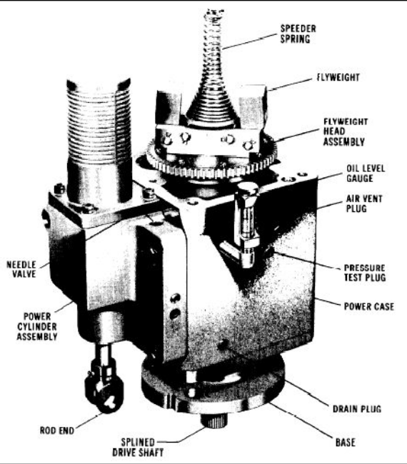
*COMPONENTS
1. Internal oil pump: with oil accumulator/relief valve maintain oil press.
2. Flyweight head-pilot valve assembly:
controls flow of oil to power cylinder assembly
3. Power Cylinder Assembly (servomotor)
positions fuel rack.
4. Compensation system: stabilizes governor system
5. Lever speed-setting mechanism: adjusts the governor speed setting.

INTERNAL COMPONENTS OF GOVERNOR
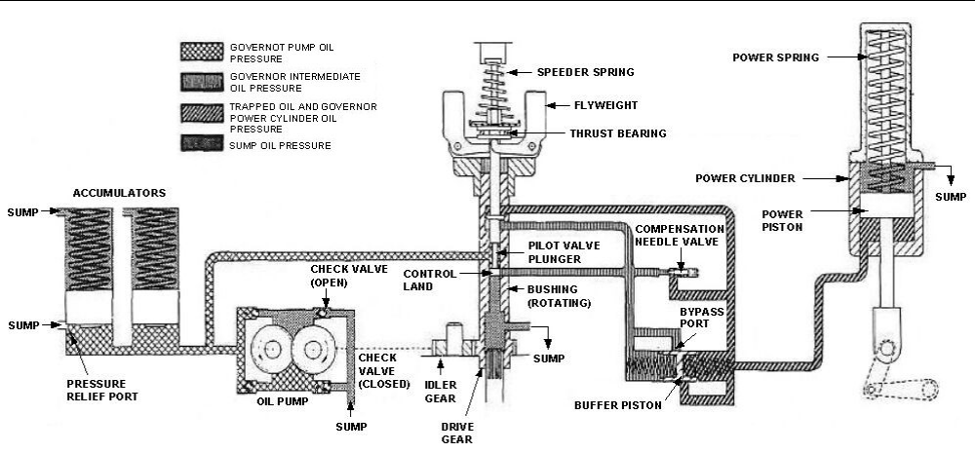

*GOVERNOR DRIVE SHAFT: is mechanically linked to engine, so it rotates at the same speed. The drive gear turns the idler gear, which then draws oil from the sump.
*PILOT VALVE PLUNGER: is controlled by the centrifugal force of the flyweights and the downward force of the speeder spring.
IF | THEN
Plunger is centered | Power piston is stationary
Plunger is raised | Power piston moves down, decreasing fuel
Plunger is lowered | Power piston moves up, increasing fuel

IF | THEN
Forces are equal | Plunger is centered, no oil flows
Governor speed setting is same, but added load slows engine and governor | Centrifugal force decreases and plunger lowers
Engine speed is same, but speeder spring force is increased to raise governor speed setting | Plunger is lowered
Governor speed setting same, but load is removed and engine speeds up | Centrifugal force increases and plunger is raised
Engine speed is same, but speeder spring force is decreased to lower governor speed setting | Plunger is raised

*COMPENSATION SYSTEM:
Stabilizes the system using a pressure differential across the pilot valve plunger.
- Oil flows to and from the power cylinder assembly via the buffer cylinder, carrying the buffer piston in the direction of the flow.
- This compresses the buffer spring, creating a pressure differential
- The oil pressure is transmitted on one side to the lower side of the compensation land, and on the other side to the upper side of the compensation land.(on the pilot valve plunger)
- The difference in pressure helps to center the pilot valve plunger.
- The compensation needle valve sets the rate at which the pilot valve plunger will be centered. This will get you maximum stability for the system
*To adjust the compensation needle valve: With engine operating at idle, open the valve until the engine begins to hunt (search for proper speed). Then, close the valve until hunting is done. You can check it by manually disturbing the speed setting. If it returns to normal, you’re done.

*OVERSPEED TRIP:
Isolates governor from oil, causing it to go to no fuel position, or can override governor to directly trip the fuel rack to no fuel position.

GOVERNOR AND OVERSPEED TRIP
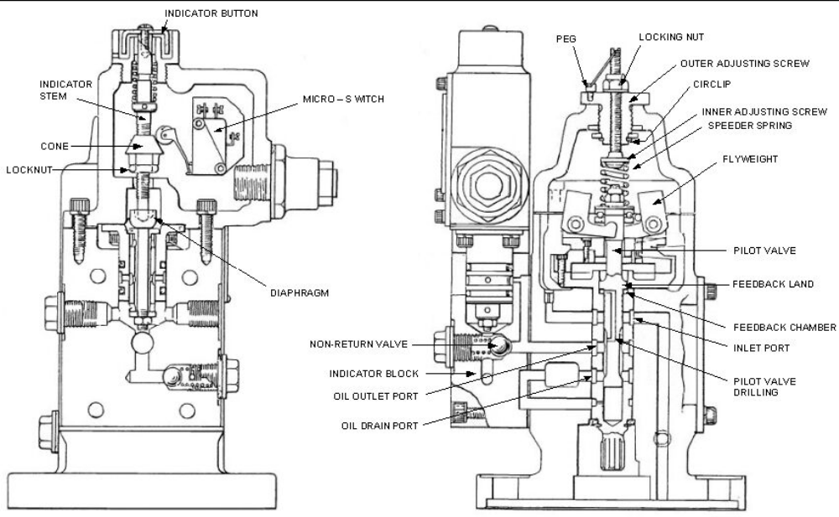

- As tripping speed is approached, centrifugal force causes the pilot valve plunger to raise above normal position.
- This allows oil to flow from the inlet port to the oil outlet port, into the indicator block, past the return valve to the overspeed shutdown portion.
- This puts the fuel rack at the no fuel position, shutting down the engine.
- Oil is also passed through a port in the indicator valve, which pushes on the diaphragm, indicator stem, and button to let you know visually.
- All oil pressure in the trip unit is relieved except for the shutdown system. This stays until the engine is reset.

There are 2 speed trip settings:
- Check Trip Speed: speed below the operating speed of engine
- Overspeed: speed above the operating speed of engine. Checked by manually overriding the governor.

*FUEL INJECTORS:
Meters required amount
Atomizes fuel
Times moment of injection
High pressure required for injection

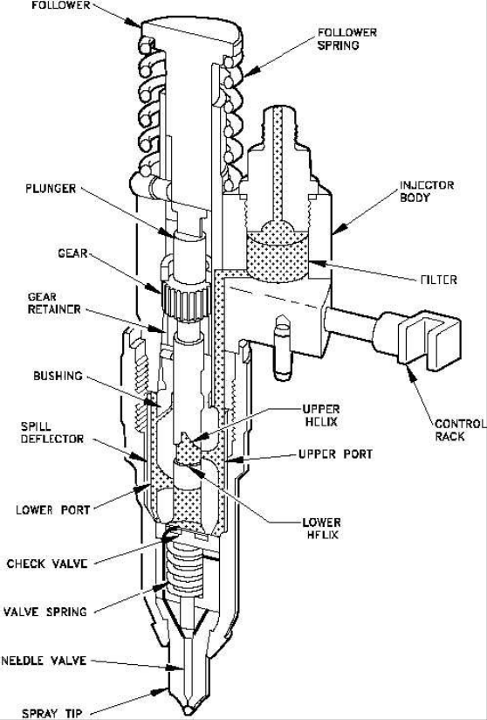
- Fuel enters through inlet side and into filter.
- Fuel then enters the supply chamber via drilled passages.
- The plunger operated up and down in the bushing. Fuel is supplied through the upper and lower ports, which are funnel shaped.

*There are 2 ways to adjust the injectors;

DIAL INDICATOR

TORQUE

BOAT MAINTENANCE
(NEM, COMDTINST M9000.6E, CH 081)

LEVELS OF MAINTENANCE
*Organized Level Maintenance: performed by unit’s crew, MAT, or contractor under unit’s supervision.
*Intermediate level Maintenance: More sophisticated, requiring outside help; MAT, sector, contracted help.
*Depot Level Maintenance: requiring major overhaul of complete rebuild. Usually performed during dry-dock/dockside availability with outside help.

TYPES OF MAINTENANCE
*Corrective Maintenance: scheduled and unscheduled tasks that restore equipment after casualty has occurred. (CASREP)
(CSMP) Corrective Ship’s Maintenance Projects: documents corrective maintenance needs only.
*Preventative Maintenance: minimum maintenance requirements.
*Alterative Maintenance: improves system performance by changing configuration.

TYPE OF MAINT.
CORRECTIVE
PREVENTATIVE
ALTERATIVE

INSPECTIONS, RECORDS, REPORTS, AND TESTS
(NEM, COMDTINST M9000.6E, CH 090)

*Routine/Periodic Inspections: CO/OIC conducts, required. Frequent. Repairs noticed during inspections will be entered into CSMP.
*Double Bottoms, Voids, Ballast Tanks: shall be inspected annually. Pay attention to sounding tubes and striker plates. If you find rust, use rust converter and re-inspect no more than 90 days later.
*Safety Devices: Inspected during PMS.
*Thermo graphic Inspection: of electrical system. Entered into Maint. History or CMplus.
*Fresh Water and Reserve Tanks: Inspected annually or when emptied and opened for any purpose. Entered into Hull History, sterilize tanks after inspection.
*Fuel Tanks: Inspected according to CMP, only cleaned when needed.

RECORDS

*Hull History: All cutters 65’ and up required. Units with CMplus shall record hull history there.
Hull Board Results
Hull Potential Surveys
Underwater Body Inspection Reports
*Machinery History: All cutters 65’ and up required. Units with CMplus shall record maintenance history there.
Alterations to machinery
Part numbers
Work completed
Resistance Test Record Card (electronics)
*CSMP File: tabulates all outstanding repairs.
*Machinery Log: daily records for shipboard machinery
At sea, 4 hour watches signed by EOW.
In port, 0000-0900, 0900-1600, and 1600-2400 signed by EOW.
Signed daily by EO/EPO.
*Engineer’s Bell Book: Form CG-2930, cutters 110’ and up. When cutter is under engineering control, log when bells from bridge are answered. When cutter is under bridge control, no bell book entries.
*Operating Record: 65’ and up…

MDE

Boiler Log
Evap Log
Reefer Log
Aux equip Log
*Fuel and Water Log: kept by FOWK
*EO/EPO night orders

REPORTS

*Cutter Engineering Report: Form CG-4874. Annually, no later than 31 January.
*Boat Inspection Report: Form CG-3022. All boats less than 65’ long, except for boats with outboards. Annually, submitted to MLC within 10 days of inspection.

6 PARTS OF BOAT RECORDS:

- Boat Record Book (hull and machinery history)
- Boat Inspection Reports (kept for 3 years)
- CASREPS and CASCORS
- ECR Pending
- ECR Completed
- Pending CSMP

INTERNAL COMBUSTION ENGINE REGULATIONS
(NEM, COMDTINST M9000.6E, CH 233)

JACKET WATER TREATMENT PROGRAM

*Make-up Water Requirements:
1. conductivity not exceed 150 ohms/cm.
2. Chloride concentration not exceed 60 ppm.

*Cleaning: use inhibited hydrochloric acid to clean badly scaled systems.

*Inhibitor Treatments:
- NAVCOOL 2000 and PENCOOL 2000: inhibitor chemicals in an aqueous solution. Do not use on systems with aluminum components
- NAZCOOL 3000 and PENCOOL 3000: similar to 2000, but also protects against precipitates and gel deposits. Do not use on systems with aluminum components.
- MIL-A-53009 corrosion inhibitor: Used only on MDE’s that are not prone to cylinder cavitation and don’t contain aluminum components.
- NAVFLEET 9-111 inhibitor: Use on systems with aluminum components. Never mix this inhibitor with anti-freeze.
- A-A-52624 TYPE I inhibited antifreeze: ethylene glycol based, you can mix this antifreeze with the first three inhibitors.
- Caterpillar Extended Life Coolant 50/50 Premix: ethylene glycol and de-ionized water.

*Coolant Testing: utilize NEM and PMS cards for engine-specific tests and levels.

LUBRICATING OILS

*All L/O used in MDE/AUX/GEN engines in the CG are…

MIL-L-2104 SAE 15W40 or MIL-L-2104 SAE 40

TESTING AND ANALYSIS
- Only send oil to MLC designated labs
- Refer to NEM for guidance on what equipment to test
- Sampling:
  - Only use designated testing points.
  - Overhauled engines sample at 1, 25, 50 hours and then use regular standards.
  - Engines with intervals of 750 or greater shall be sampled 3 times between oil changes
  - Engines with intervals less than 750 are not required to be sampled.
  - Sample after any major engine casualty.
- Oil analysis tests:
- Spectrometric Analysis for wear:
LEAD ALUMINUM
SILICON MOLYBDENUM
MAGNESIUM NICKEL
COPPER SILVER
CHRONIUM TIN
IRON ZINC
- Particle Count Analysis (CPP and Hydraulic systems only)

CMPLUS

LOCAL MAINTENANCE PROCEDURES

*Meet specific needs of a local unit, not included in official PMS.
*Scheduled with PMS based on periodicity.
1. Create Local Maintenance Procedure.
2. Link Procedure to a Configuration Item (CI)
3. Add procedure details.

INITIALIZING MASTER TASKS
*Links Master task to Maintenance Procedure.
*Activates the Maintenance Task which will be put into the Maintenance Scheduler.
1. Go to Initialize Master Task
2. Enter the procedure number.
3. Enter information
*You may need to split the master tasks for multiple CI’s.

ASSIGN A LOCAL MAINTENANCE TASK TO MAINTENANCE SCHEDULE
  - Open maintenance schedule, and select update
  - Select Master Task, then find the individual task.
  - Enter the date you want it completed.

CREATE UNIT OPERATION SCHEDULE
- Select unit operation, and extend unit calendar (used at the end of the year)
- Enter the calendar year you are creating, then enter boat status.

PROPOGATE UNIT SCHEDULE
*Same as annual schedule, just select weekly, monthly…ect.

UPDATE LOCAL MAINTENANCE PROCEDURES
*Change requirements to meet local restrictions:
Environmental concerns
Department Changes
Change of equipment
Change of Billets
- Go into the Local screen, and select update
- Enter your new data
- You may need to link this procedure to multiple CI’s

UPDATE MASTER TASKS
- Select review/edit master tasks and select your task.
- Go into the update mode, and change the info.

